TASK 3

1.Multi-Layer Banking System

import java.util.Scanner;
class InsufficientBalanceException extends Exception {
public InsufficientBalanceException(String message) {
super(message);
}
}
class AccountManager {
private double balance;

public AccountManager(double balance) {
this.balance = balance;
}
public void withdraw(double amount) throws InsufficientBalanceException {
if (amount > balance) {
throw new InsufficientBalanceException("Insufficient balance in account");
}
balance -= amount;
System.out.println("Withdrawal Successful. Remaining Balance: " + balance);
}
}
class BankService {
private AccountManager accountManager;
public BankService(AccountManager accountManager) {
this.accountManager = accountManager;
}
public void processWithdrawal(double amount) throws InsufficientBalanceException {
accountManager.withdraw(amount);
}
}
public class Main {
public static void main(String[] args) {
Scanner sc = new Scanner(System.in);

System.out.print("Enter balance: ");
double balance = sc.nextDouble();

System.out.print("Enter withdrawal: ");
double withdrawalAmount = sc.nextDouble();

AccountManager manager = new AccountManager(balance);
BankService bankService = new BankService(manager);

try {
bankService.processWithdrawal(withdrawalAmount);
} catch (InsufficientBalanceException e) {
System.out.println("Transaction Failed");
System.out.println("Reason: " + e.getMessage());
}

sc.close();
}
}
Output:
Enter balance: 700
Enter withdrawal: 49
Withdrawal Successful. Remaining Balance: 651.0

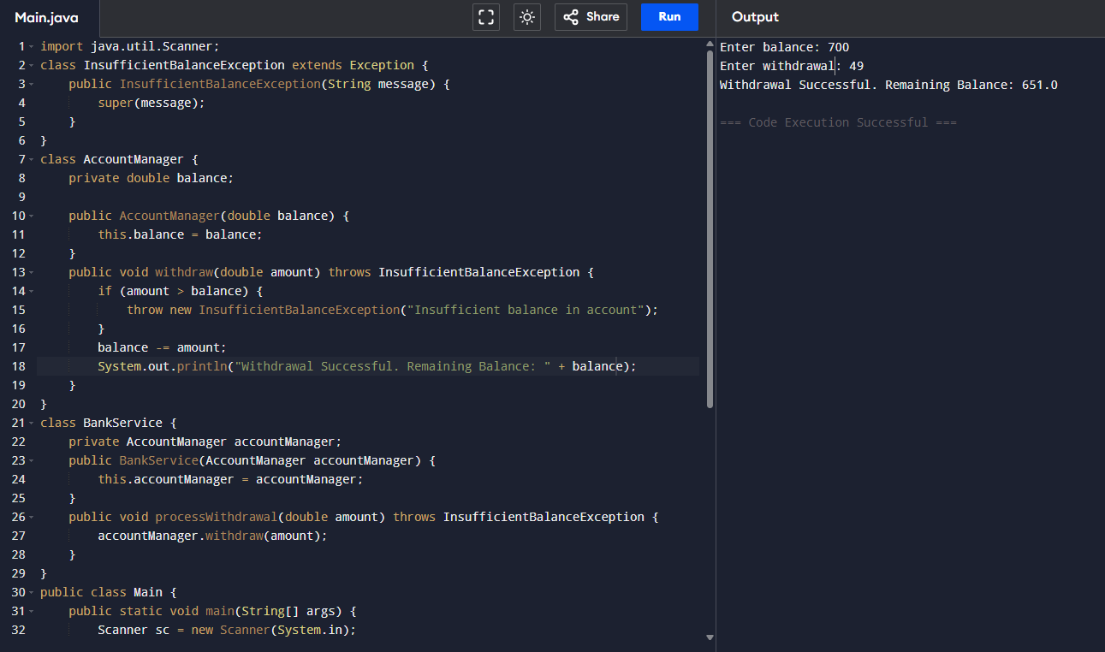

2. Online Exam Result System (Multiple Custom Exceptions)
import java.util.Scanner;

// Custom Exception 1: InvalidMarksException
class InvalidMarksException extends Exception {
public InvalidMarksException(String message) {
super(message);
}
}

// Custom Exception 2: FailException
class FailException extends Exception {
public FailException(String message) {
super(message);
}
}

// Result Evaluation System
class ResultEvaluator {
public void evaluate(int marks) throws InvalidMarksException, FailException {
if (marks < 0 || marks > 100) {
throw new InvalidMarksException("Marks must be between 0 and 100");
} else if (marks < 35) {
throw new FailException("Student failed the exam");
} else {
System.out.println("Result: Pass");
}
}
}

public class Main {
public static void main(String[] args) {
Scanner sc = new Scanner(System.in);

System.out.print("Enter student mark: ");
int marks = sc.nextInt();

ResultEvaluator evaluator = new ResultEvaluator();

try {
evaluator.evaluate(marks);
} catch (InvalidMarksException e) {
System.out.println("Result: InvalidMarksException – " + e.getMessage());
} catch (FailException e) {
System.out.println("Result: FailException – " + e.getMessage());
}

sc.close();
}
}
Output:
Enter student mark: 78
Result: Pass
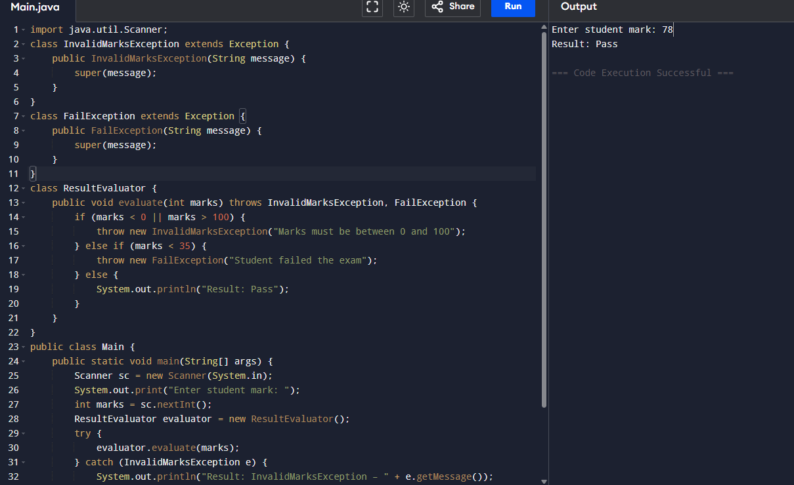

3. File Data Processing System
import java.io.*;
public class Main {
public static void main(String[] args) {
String fileContent = "10\n20\n30\nabc\n40";
int sum = 0;
int count = 0;

try (BufferedReader br = new BufferedReader(new StringReader(fileContent))) {
String line;
while ((line = br.readLine()) != null) {
try {
int num = Integer.parseInt(line.trim());
sum += num;
count++;
} catch (NumberFormatException e) {
System.out.println("Warning: Skipping invalid number -> " + line);
}
}

if (count > 0) {
double average = (double) sum / count;
System.out.println("Average of valid numbers: " + average);
} else {
System.out.println("No valid numbers to process");
}

} catch (IOException e) {
System.out.println("Error: Problem reading the file");
}
}
}
Output:
Warning: Skipping invalid number -> abc
Average of valid numbers: 25.0
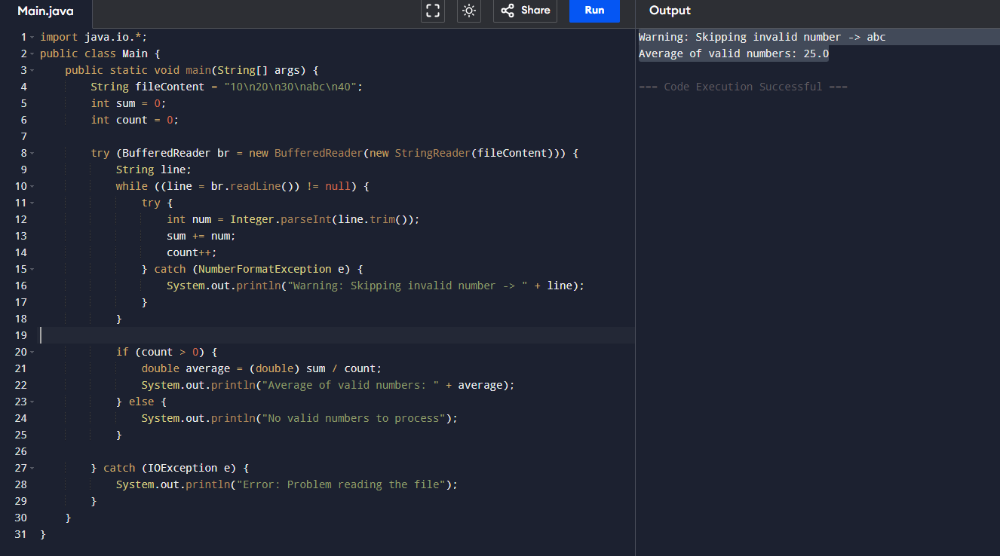

4. ATM Transaction Retry Mechanism

import java.util.Scanner;
class AccountLockedException extends Exception {
public AccountLockedException(String message) {
super(message);
}
}
public class Main {
public static void main(String[] args) {
final int CORRECT_PIN = 1234;
final int MAX_ATTEMPTS = 3;
int attempts = 0;
Scanner sc = new Scanner(System.in);

while (attempts < MAX_ATTEMPTS) {
System.out.print("Enter PIN: ");
int enteredPin = sc.nextInt();

if (enteredPin == CORRECT_PIN) {
System.out.println("Access Granted!");
sc.close();
return;
} else {
attempts++;
System.out.println("Incorrect PIN.");
}
}
sc.close();
try {
throw new AccountLockedException("Too many failed attempts");
} catch (AccountLockedException e) {
System.out.println(e);
}
}
}
Output:
Enter PIN: 12324
Incorrect PIN.
Enter PIN: 1234
Access Granted!
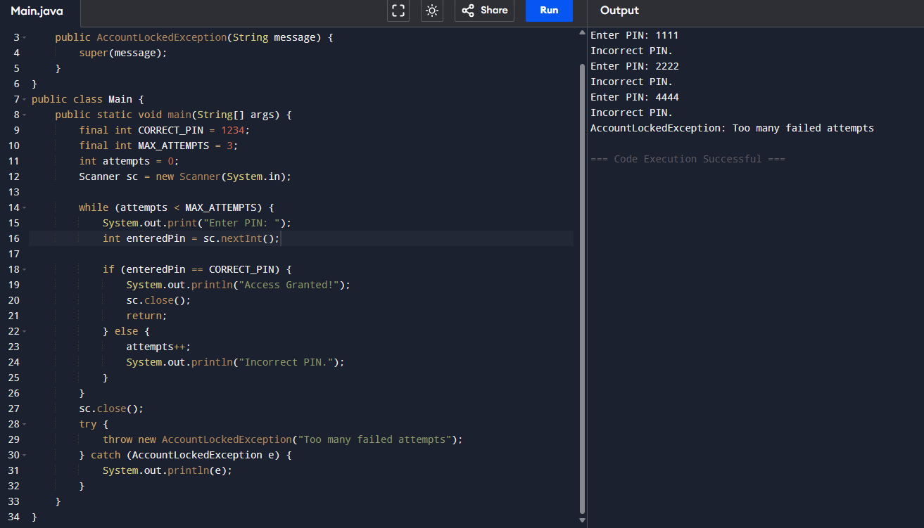

5. E-Commerce Order Processing
import java.util.Scanner;

// Custom exception for out-of-stock products
class OutOfStockException extends Exception {
public OutOfStockException(String message) {
super(message);
}
}

// Custom exception for payment failure
class PaymentFailedException extends Exception {
public PaymentFailedException(String message) {
super(message);
}
}

public class Main {
public static void main(String[] args) {
Scanner sc = new Scanner(System.in);

try {
// Step 1: Validate product stock
System.out.print("Enter product quantity: ");
int quantity = sc.nextInt();

System.out.print("Available stock: ");
int stock = sc.nextInt();

if (quantity > stock) {
throw new OutOfStockException("Product out of stock");
}

// Step 2: Validate payment
System.out.print("Enter payment amount: ");
double payment = sc.nextDouble();

// For demonstration, let's assume order total = quantity * 100
double orderTotal = quantity * 100;

if (payment < orderTotal) {
throw new PaymentFailedException("Insufficient payment");
}

// Step 3: Confirm order
System.out.println("Order Confirmed!");
} catch (OutOfStockException | PaymentFailedException e) {
System.out.println("Order Failed");
System.out.println("Reason: " + e.getMessage());
} catch (Exception e) {
System.out.println("Order Failed");
System.out.println("Reason: Invalid input");
} finally {
sc.close();
}
}
}
Output:
Enter product quantity: 10
Available stock: 23
Enter payment amount: 3400
Order Confirmed!
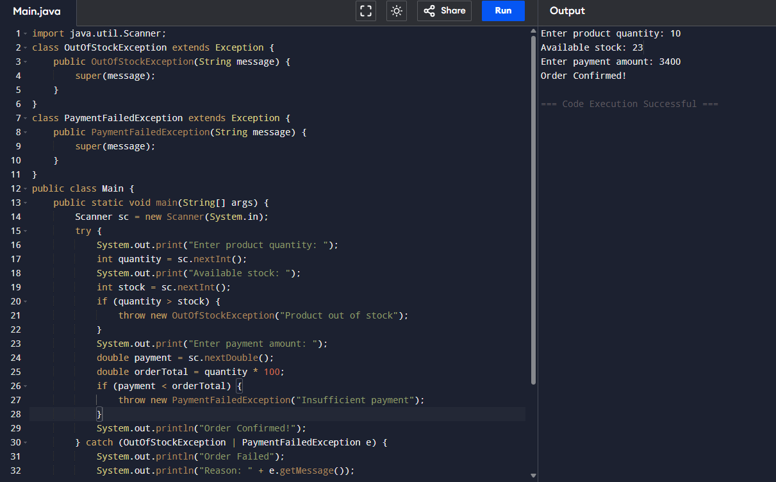

. Dynamic Class Loading System

import java.util.Scanner;
class OutOfStockException extends Exception {
public OutOfStockException(String message) {
super(message);
}
}
class PaymentFailedException extends Exception {
public PaymentFailedException(String message) {
super(message);
}
}
public class Main {
public static void main(String[] args) {
Scanner sc = new Scanner(System.in);
try {
System.out.print("Enter product quantity: ");
int quantity = sc.nextInt();
System.out.print("Available stock: ");
int stock = sc.nextInt();
if (quantity > stock) {
throw new OutOfStockException("Product out of stock");
}
System.out.print("Enter payment amount: ");
double payment = sc.nextDouble();
double orderTotal = quantity * 100;
if (payment < orderTotal) {
throw new PaymentFailedException("Insufficient payment");
}
System.out.println("Order Confirmed!");
} catch (OutOfStockException | PaymentFailedException e) {
System.out.println("Order Failed");
System.out.println("Reason: " + e.getMessage());
} catch (Exception e) {
System.out.println("Order Failed");
System.out.println("Reason: Invalid input");
} finally {
sc.close();
}
}
}
Output:

Enter class name: java.util.Scanner;
ERROR!
Error: Class not found
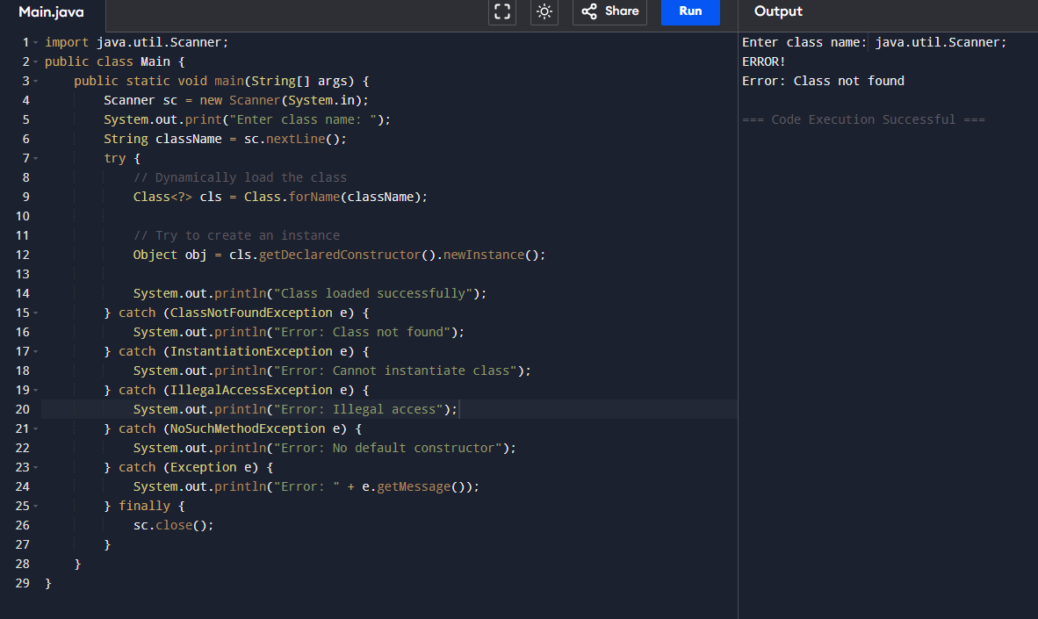

Data Validation Framework
import java.util.Scanner;
class ValidationException extends Exception {
public ValidationException(String message) {
super(message);
}
}
public class Main {
static void validateUser(String username, String email, String password) throws ValidationException {
try {
if (username == null || username.isEmpty()) {
throw new ValidationException("Username cannot be empty");
}
if (email == null || !email.contains("@")) {
throw new ValidationException("Invalid email format");
}
if (password == null || password.length() < 6) {
throw new ValidationException("Password must be at least 6 characters");
}
} catch (ValidationException e) {
// Rethrow to main
throw e;
}
}
public static void main(String[] args) {
Scanner sc = new Scanner(System.in);

System.out.print("Enter username: ");
String username = sc.nextLine();

System.out.print("Enter email: ");
String email = sc.nextLine();

System.out.print("Enter password: ");
String password = sc.nextLine();

try {
validateUser(username, email, password);
System.out.println("User registration successful!");
} catch (ValidationException e) {
System.out.println("Validation Error: " + e.getMessage());
} finally {
sc.close();
}
}
}
OUTPUT:
Enter username: john
Enter email: testgmail.com
Enter password: 123456
ERROR!
Validation Error: Invalid email format
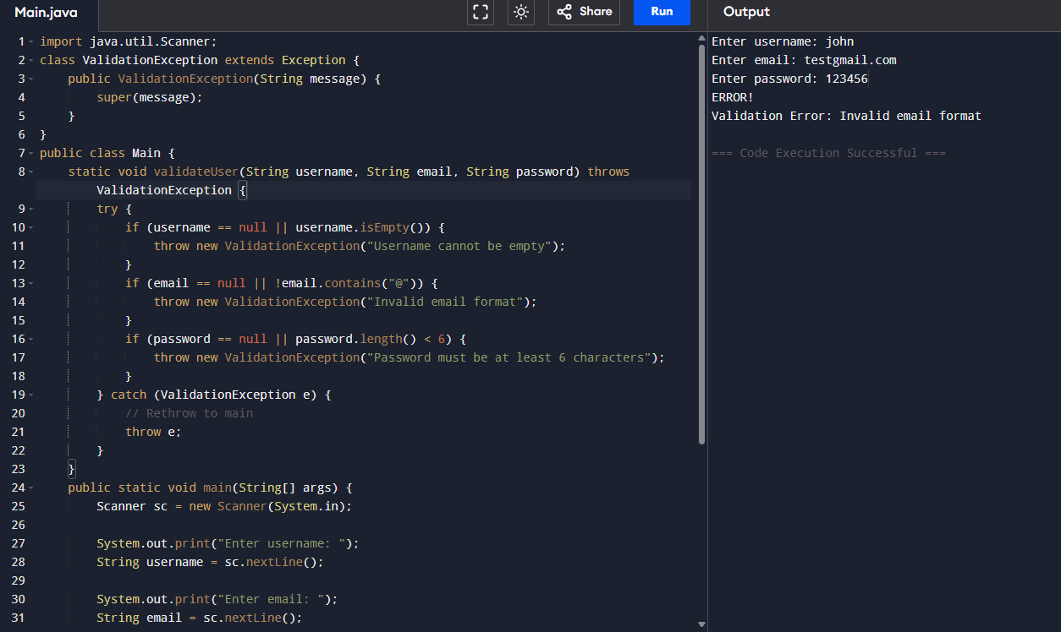

Parallel Task Executor
class NumberPrinter extends Thread {
private int max;
public NumberPrinter(int max) {
this.max = max;
}
@Override
public void run() {
try {
for (int i = 1; i <= max; i++) {
System.out.println("Thread1: " + i);
Thread.sleep(200); // simulate delay
}
} catch (InterruptedException e) {
System.out.println("Thread1 interrupted");
}
}
}

class AlphabetPrinter extends Thread {
private int max;

public AlphabetPrinter(int max) {
this.max = max;
}

@Override
public void run() {
try {
for (int i = 0; i < max; i++) {
char ch = (char) ('A' + i);
System.out.println("Thread2: " + ch);
Thread.sleep(200); // simulate delay
}
} catch (InterruptedException e) {
System.out.println("Thread2 interrupted");
}
}
}

public class Main {
public static void main(String[] args) {
int n = 5; // number of elements to print

Thread t1 = new NumberPrinter(n);
Thread t2 = new AlphabetPrinter(n);

t1.start();
t2.start();

try {
t1.join();
t2.join();
} catch (InterruptedException e) {
System.out.println("Main thread interrupted");
}

System.out.println("All tasks completed!");
}
}
Output:
Thread1: 1
Thread2: A
Thread1: 2
Thread2: B
Thread1: 3
Thread2: C
Thread1: 4
Thread2: D
Thread1: 5
Thread2: E
All tasks completed!
